EdTech Talk
Date : 5 March 2017 Time : 9.00-12.00 / Audience 32 persons
Theme: Grand Opening and Relax
Active Learning and Challenging
Crazy Journey to Opening Learning World

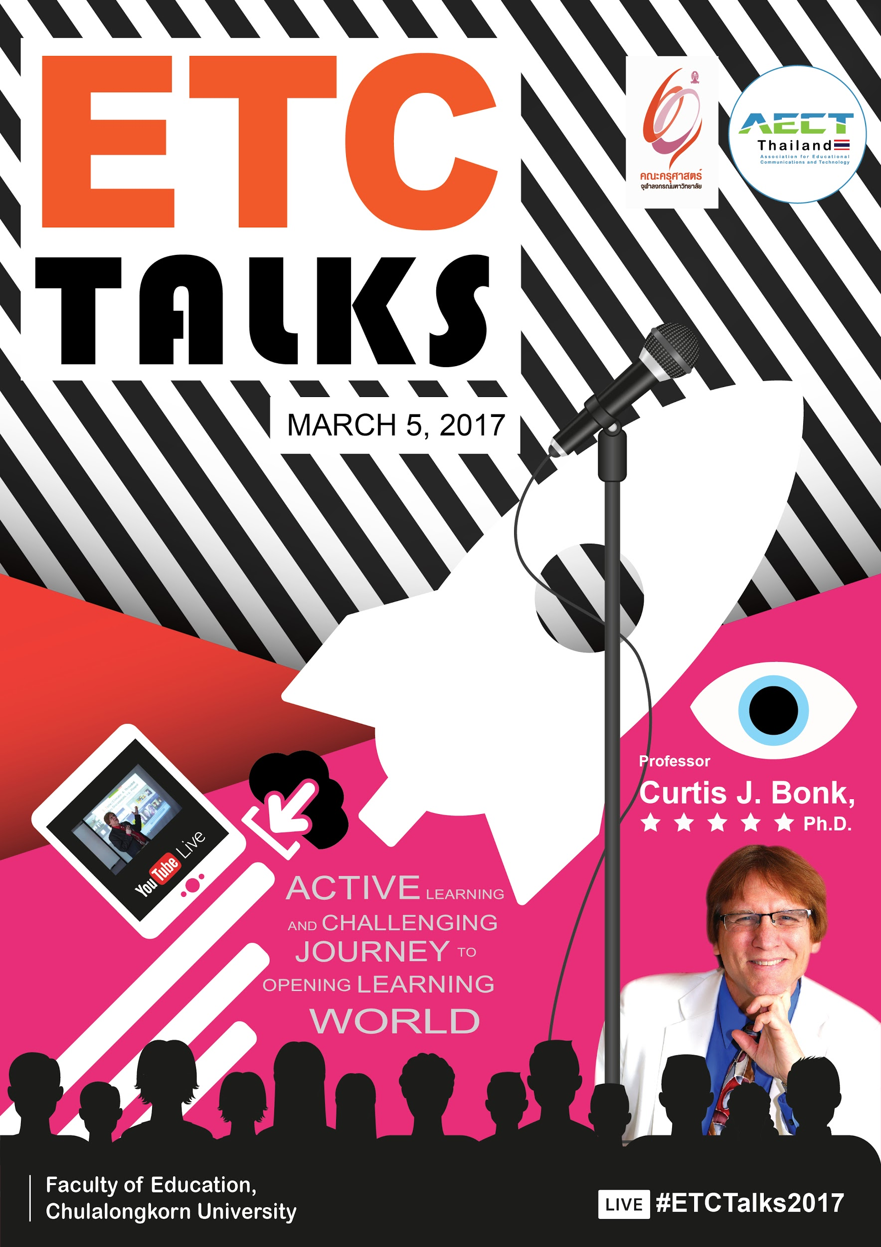

Live 09.15 A.M
Time | Detail | Remarks
09.15-09.20 | Mc : say hello and introduce President of chulalongkorn university, Dean of faculty of education , President of Technology Education Association, Head of ETC department and Faculties.
09.20-09.30 | MC : introduce game  “word crowd”  When you hear  “ The world is open” what is come up on your mind? | “Link Game”  The world is open : https://answergarden.ch/437757
09.30-10.15 | 4-5 Audiences brings up book exerpts:  Bonk responds/talks
10.15-10.35 | Take a break | Activity with robot during break : Audiences answer questions to get the price to be a true fan of faculty of education, chulalongkorn university
10.35-11.30 | 4-5 Audiences brings up book exerpts:  Bonk responds/talk (continue)

